LAB ASSIGNMENT – 6.4
Anyam Akshitha
2303A52453
Batch – 42

Task 1: Student Performance Evaluation System

PROMPTS USED:
complete method to display student details.
complete method to check if marks are above class average.

CODE:
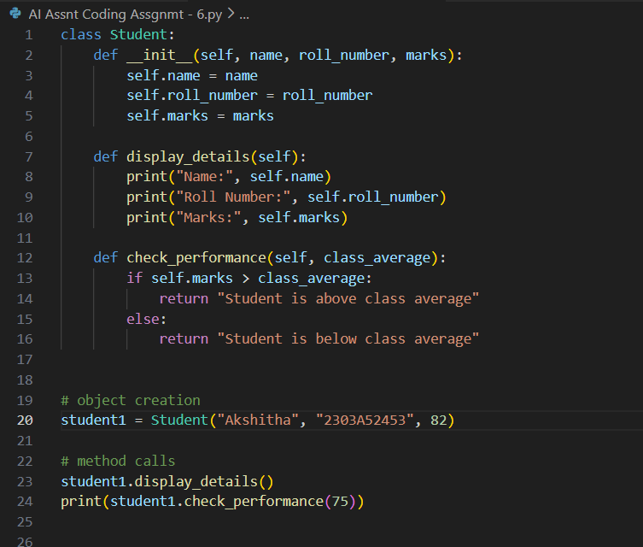
OUTPUT:

JUSTIFICATION:
This task demonstrates AI-assisted completion of class methods using conditionals and self attributes, ensuring clean and readable object-oriented code.

Task 2: Data Processing in a Monitoring System

PROMPTS USED:
check if number is even
calculate square and print result

CODE:
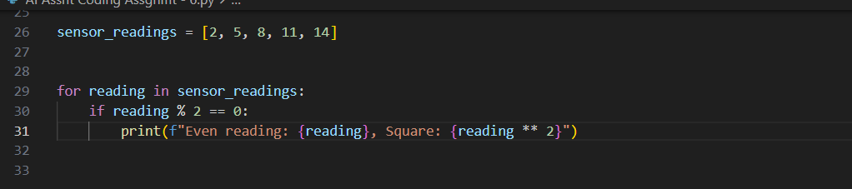

OUTPUT:

JUSTIFICATION:
AI successfully generated loop logic using modulus and conditional statements, meeting the monitoring system requirements.

Task 3: Banking Transaction Simulation

PROMPTS USED:
method to deposit money
method to withdraw money with balance check

CODE:
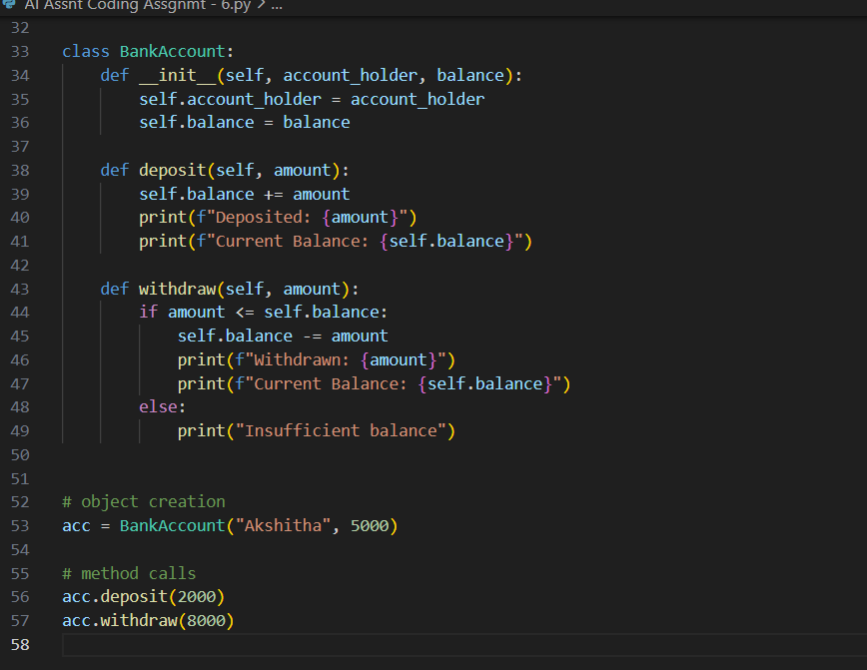

OUTPUT:

JUSTIFICATION:
The AI-generated methods correctly use conditionals to prevent invalid withdrawals, ensuring secure transaction handling.

Task 4: Student Scholarship Eligibility Check

PROMPT USED:
use while loop to check scores greater than 75

CODE:
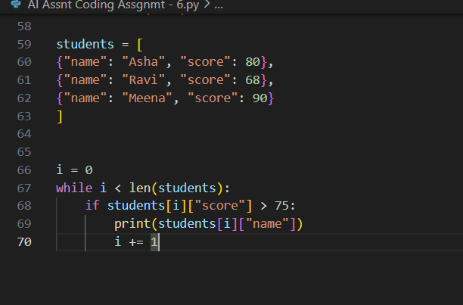

OUTPUT:
JUSTIFICATION:
This task shows effective AI assistance in generating a while loop with proper index handling and conditional checks.

Task 5: Online Shopping Cart Module

PROMPTS USED:
add item to cart
remove item from cart
calculate total with discount

CODE:
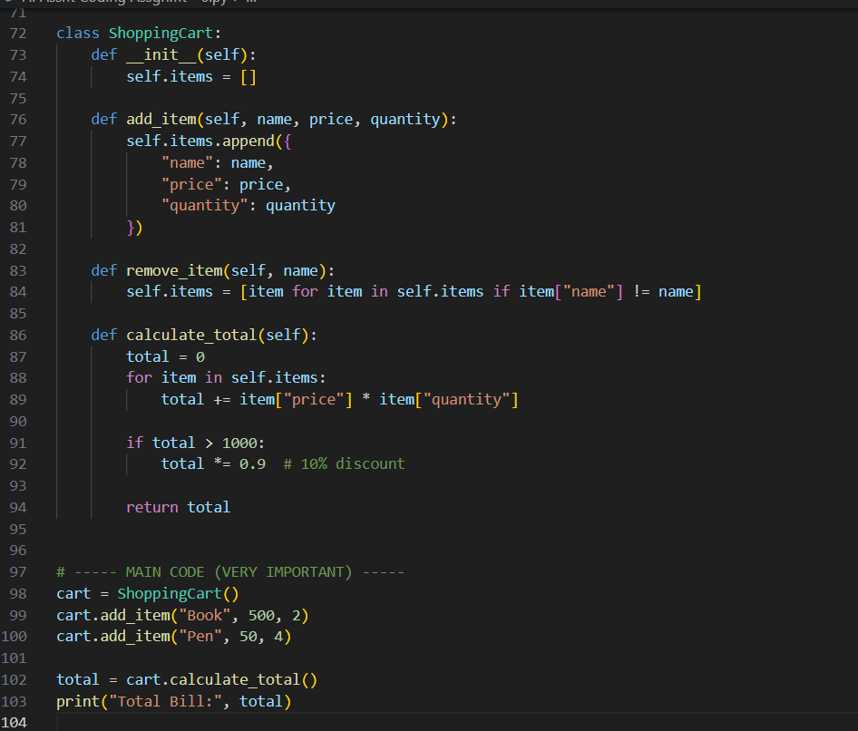
OUTPUT:
JUSTIFICATION:
AI-generated loops and conditional discount logic ensure accurate cart management and billing functionality.

